

**National University of Modern Languages**

**PROGRAMMING FUNDAMENTALS**

**Spring 2024**

**LAB 3**

**NAME: IFFAT**

**ROLL NUMBER: 3357**

**PROGRAM: BSCS (1ST SEMESTER)**

**SECTION: A**

**SUBMITTED TO: Ms. Shumaila Qayyum**

1. Write a program to display ASCII equivalent of your name (capital first letter)

**Code:**

#include<iostream>

using namespace std;

int main()

{

int i,f,a,t;

i='I';

f='f';

a='a';

t='t';

cout<<"I="<<i<<"\nf="<<f<<"\nf="<<f<<"\na="<<a<<"\nt="<<t;

}

**OUTPUT:**

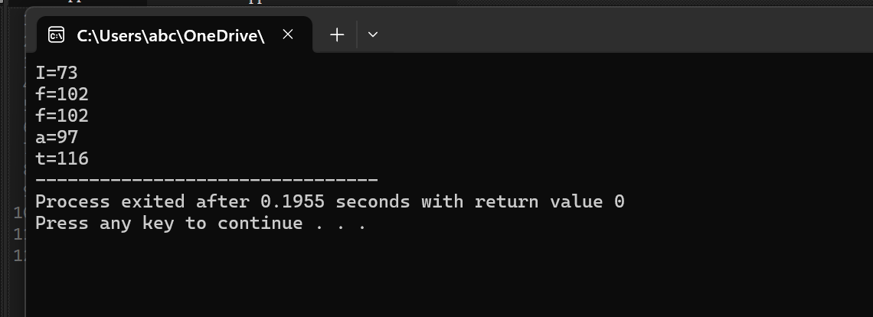

1. Write a program that takes two numbers from user and perform addition, subtraction, multiplication and division.

**Code:**

#include<iostream>

using namespace std;

int main()

{

int a,b,sum,diff,prod,div;

cout<<" Enter two numbers:";

cin>>a>>b;

sum=a+b;

diff=a-b;

prod=a*b;

div=a/b;

cout<<" Sum of numbers:"<<sum<<endl;

cout<<" Product of numbers:"<<prod<<endl;

cout<<" Difference of numbers:"<<diff<<endl;

cout<<" Quotient of numbers:"<<div<<endl;

}

**OUTPUT:**

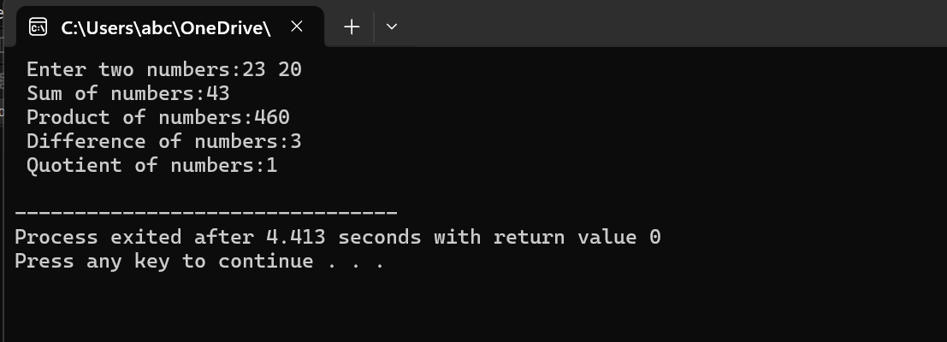

1. Write a program that inputs a char , int and float it converts each data into its equivalent data type. Show the message to user which display actual data and the data type to which it is converting and equivalent.

**Code:**

#include<iostream>

using namespace std;

int main ()

{

int a;

char b;

float c;

cout<<" Enter an integer :";

cin>>a;

b=a;

cout<<" character equivalent:"<<b<<endl;

c=a;

cout<<" float equivalent: "<<c<<endl;

cout<<" Enter a character:";

cin>>b;

a=b;

cout<<" integer equivalent:"<<a<<endl;

c=b;

cout<<" float equivalent : "<<c<<endl;

cout<<" Enter a decimal:";

cin>>c;

b=c;

cout<<" character equivalent : "<<b<<endl;

a=c;

cout<<" integer equivalent :"<<a<<endl;

return 0;

}

**OUTPUT:**

